**PAST SCENARIO**

1. **Introduction to electric vehicles (EVs):**

Electric Vehicles are those vehicles which run with the help of electric motors. It was firstly invented in late 1820s and 1830s. But it commercially available during the 1890s. As in past the cost of EVs were high with low – speed and short range the demand declines initially.

And we can also say that because of lack of charging facility also the demand seems less in past scenario.

The technology was not that developed in 19th century. Technicians facing the issue of High-Cost equipment. There were lead acid batteries which were heavy and had limited energy destiny. And unlike today, there was no charging infrastructure for electric vehicles in the 19th century. And this becomes challenging factor in growth development of EVs.

**PRESENT SCENARIO**

Today the demand for EVs raising day by day as it’s a device which use electricity to run or charge their batteries instead of using petrol or diesel. Electric Vehicles are more efficient and ecofriendly as compared to petroleum vehicles as it emits less toxic gas. And in today era the infrastructure and equipment also well develop and government also taking initiatives to raise the demand of EVs.

In today’s era the demand of EVs reach its peak globally because of increase in environment pollution so government starts taking initiative as EVs is environmental friendly.

And the majority sales are mainly concentrated in three markets – China, Europe and the United States. And China is most EVs seller by selling 60% of global electric vehicles. Today, more than half of all electric cars on the road worldwide are in China. Europe and the United States, come as the second and third largest markets, both show strong growth with sales increasing 15% and 55% respectively in 2022.

And following charts show the sales of these three countries.

China Europe United States

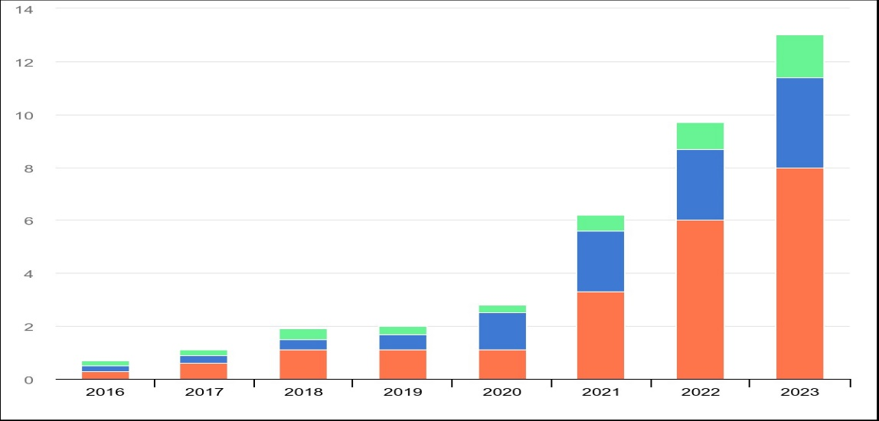

**FUTURE SCENARIO:**

Electric vehicles have been gaining popularity worldwide as people become increasingly aware of the adverse effects of fossil fuel-powered vehicles on the environment.

The global Electric vehicle (EV) sector is expected to expand at a compound annual growth rate of 15.9% between 2023 and 2035.

By some [report](https://www.globaldata.com/store/report/ev-market-analysis/) the EVs market is expected to register a CAGR OF 26.1% during this period, while the commercial EV sector is predicted to growth of 15%. The sale of battery electric passenger cars is predicted to reach 44 million units by 2035, representing huge growth rate compared with 7.3 million units sold in 2022.